ENG 250 (Graphic Novel: Halbert, Spring 2026)
Final Exam Quotation Guide

QUOTE: This would be a good death… but not good enough.

SOURCE: FRANK MILLER, Batman: The Dark Knight Returns. Page 14

QUOTE: ”You loved it so much…you jumped and danced like a fool…you remember…you remember that night”

SOURCE: AUTHOR : Frank Miller TITLE : The Dark Knight Returns BOOK/VOL/PAGE# (IF APPLICABLE: Vol1 P14

QUOTE: …BORN HERE. ONCE AGAIN, HE’S BROUGHT ME BACK- - TO SHOW ME HOW LITTLE IT HAS CHANGED, IT’S OLDER, DIRTIER, BUT- - - -IT COULD HAVE HAPPENED YESTERDAY. IT COULD BE HAPPENING RIGHT NOW. THEY COULD BE LYING AT YOUR FEET. TWITCHING, BLEEDING…

SOURCE: FRANK MILLER. BATMAN: THE DARK KNIGHT RETURNS. BOOK 1.

QUOTE: “Maybe if you’d learned to slow down... find your niche... but times have changed, and you... Well, it’s just not healthy anymore.”

SOURCE: AUTHOR : Frank Miller TITLE : The Dark Knight Returns

QUOTE: “SLICE AND DICE, WE GOT A QUOTA” “I DON’T KNOW, MAN, LOOK AT HIM. HE’S INTO IT. CAN’T DO MURDERS WHEN THEY’RE INTO IT”

SOURCE: AUTHOR : Frank Miller TITLE : BATMAN: THE DARK KNIGHT RETURNS Chapter 1

QUOTE: My parents taught me a different lesson. Lying on this street, shaking in deep shock, dying for no reason at all. They showed me that the world only makes sense when you force it to.
SOURCE: AUTHOR :Frank Miller TITLE :Batman: The Dark Knight Returns

QUOTE: THIS SHOULD BE AGONY. I SHOULD BE A MASS OF ACHING MUSCLE – BROKEN, SPENT, UNABLE TO MOVE. AND, WERE I AN OLDER MAN, I SURELY WOULD… … BUT I’M A MAN OF THIRTY – OF TWENTY AGAIN. THE RAIN ON MY CHEST IS A BAPTISM – I’M BORN AGAIN.

SOURCE: AUTHOR : Frank Miller TITLE : The Dark Knight Returns BOOK/VOL/PAGE# (IF APPLICABLE: The Dark Knight Returns 30th Anniversary Edition / page 25

QUOTE: “If war is what they want -- then I’ve got just the thing...”

SOURCE: AUTHOR : Frank Miller TITLE : The Dark Knight

QUOTE: "You don’t.... get it, boy... This isn’t a mudhole... its and operating table. And I’m the surgeon.”

SOURCE: AUTHOR : Frank Miller TITLE : The Dark Knight Returns BOOK/VOL/PAGE# (IF APPLICABLE: volume 2, pg. 42

QUOTE: 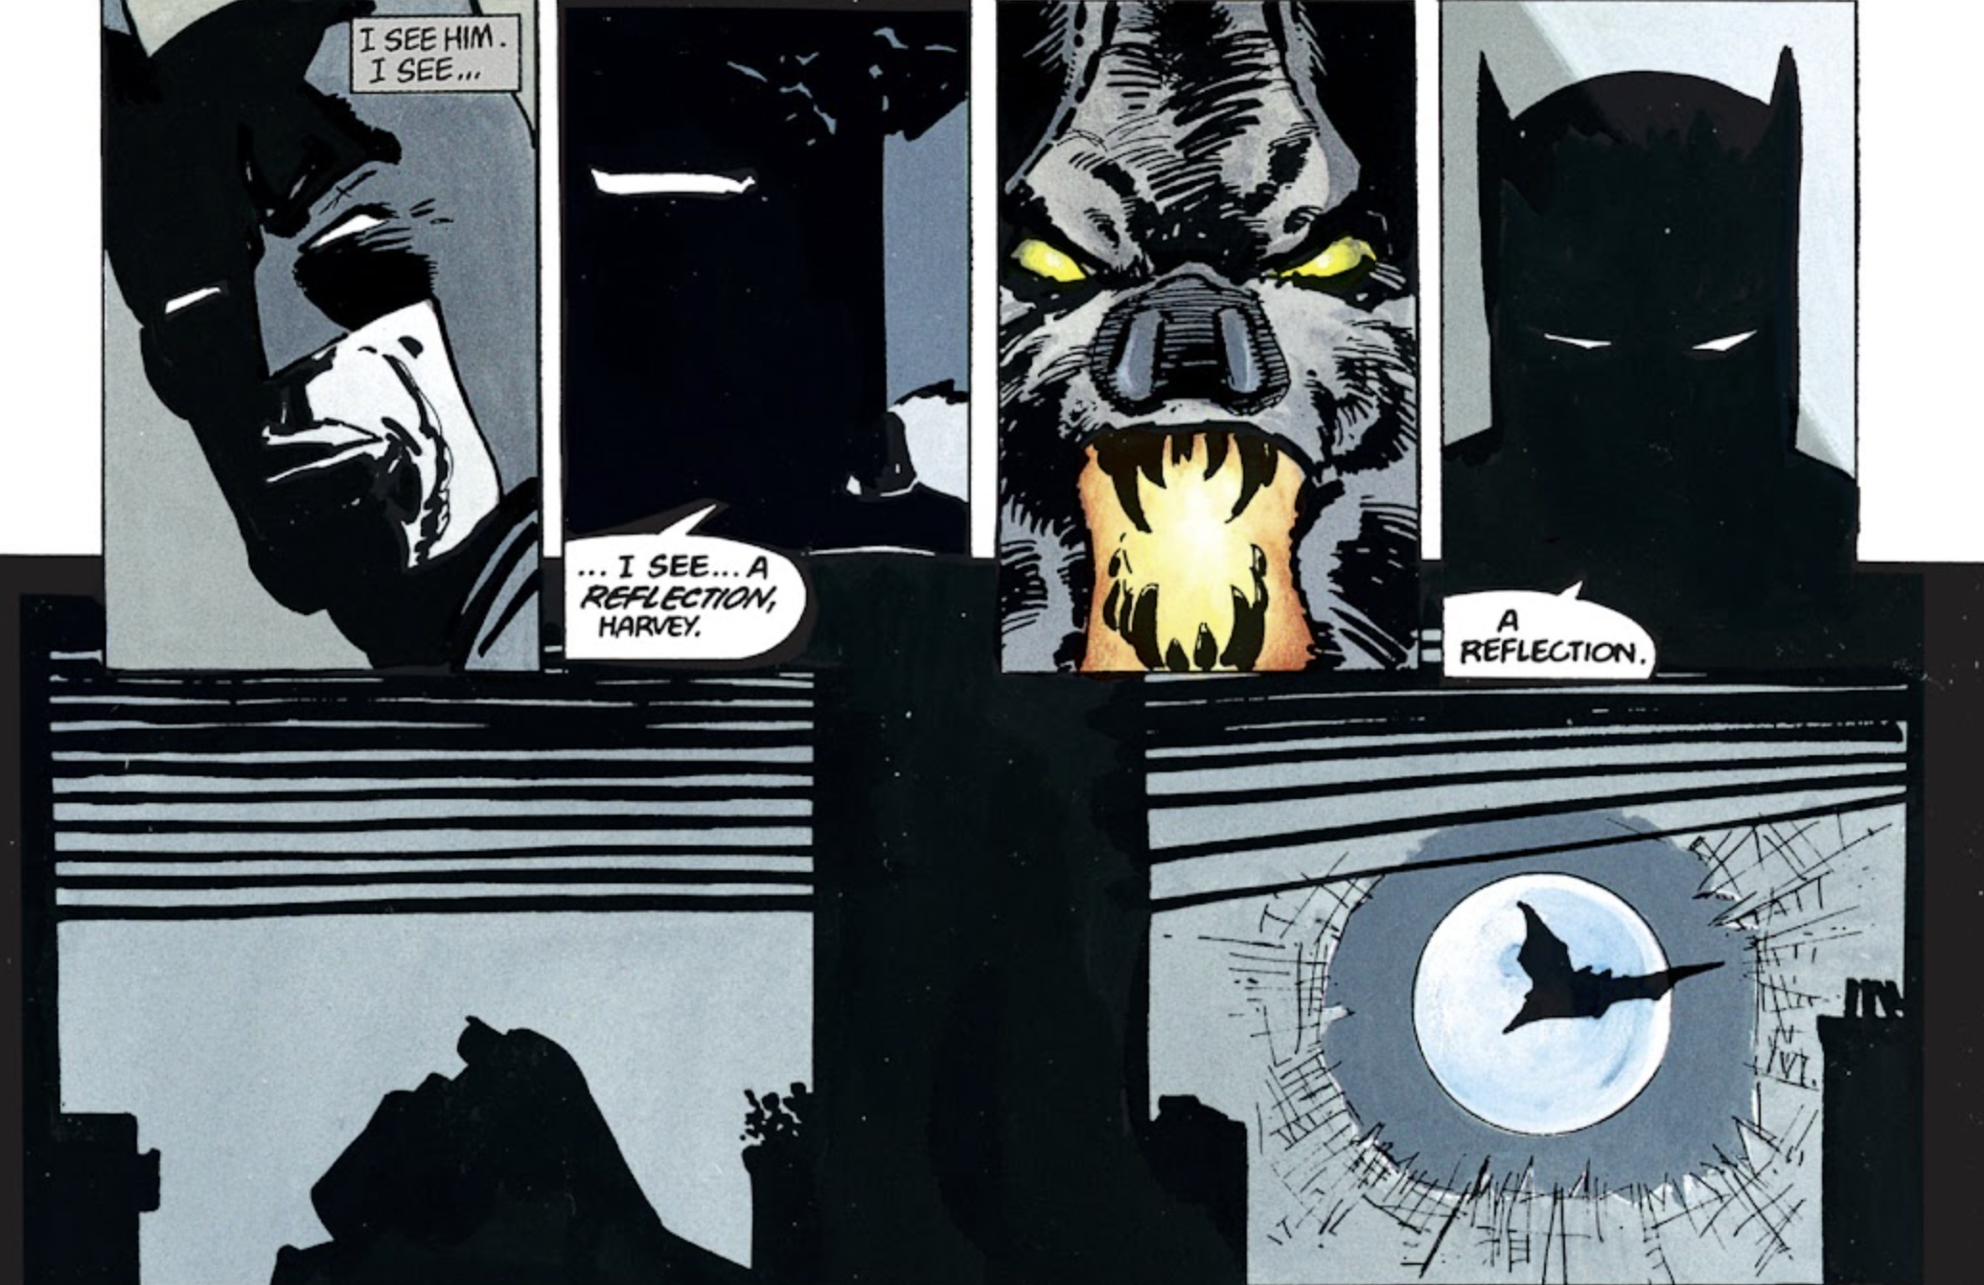

SOURCE: AUTHOR : Frank Miller TITLE : The Dark Knight Returns BOOK/VOL/PAGE# (IF APPLICABLE: volume one, pg. 46

QUOTE: Tonight, I am the Law.

SOURCE: AUTHOR : Frank Miller TITLE : The Dark Knight Returns BOOK/VOL/PAGE# (IF APPLICABLE: Book 2

QUOTE: “GOOD SOLDIER. GOOD SOLDIER”

SOURCE: AUTHOR : Frank Miller TITLE : BATMAN: THE DARK KNIGHT RETURNS BOOK/VOL/PAGE# (IF APPLICABLE: Chapter 3

QUOTE: “Darling.”

SOURCE: AUTHOR : Frank Miller TITLE : The Dark Knight Returns BOOK/VOL/PAGE# (IF APPLICABLE): Vol 1 P32

QUOTE: CAN YOU SEE IT JOKER? FEELS TO ME… LIKE ITS WRITTEN ALL OVER MY FACE. I’VE LAIN AWAKE NIGHTS PLANNING IT… PICTURING IT… ENDLESS NIGHTS… CONSIDERING EVRY POSSIBLE METHOD… TREASURING EACH IMAGINARY MOMENT… FROM THE BEGINNING I KNEW… THAT THERES NOTHING WRONG WITH YOU… THAT I CAN’T FIX… WITH MY HANDS

SOURCE: Batman: The Dark Night Returns. Frank Miller.

QUOTE: I want you to remember... the one man who beat you!

SOURCE: AUTHOR : Frank Miller TITLE : The Dark Knight Returns BOOK/VOL/PAGE# (IF APPLICABLE: Book 4

QUOTE: I wanted to see what the human race is capable of. That’s why I wrote Maus.

SOURCE: Art Spiegelman: Maus. Page 3

QUOTE: : “FRIENDS? YOUR FRIENDS?... IF YOU LOCK THEM TOGETHER IN A ROOM WITH NO FOOD FOR A WEEK…. THEN YOU COULD SEE WHAT IT IS, FRIENDS!...”

SOURCE: AUTHOR :Art Spiegelman TITLE :Maus PAGE#6

QUOTE: “Here was the first time I saw it with my own eyes, the swastika.”

SOURCE: AUTHOR : Art Spiegelman TITLE: Maus BOOK/VOL/PAGE# (IF APPLICABLE: Vol 1 P32

QUOTE: “Then you think it’s admirable to survive. Does that mean it’s NOT admirable to NOT survive?”

SOURCE: AUTHOR : Art Spiegelman TITLE : Maus Page 45

QUOTE: “It’s not about the story, it’s about the telling.”

SOURCE: AUTHOR : Art Spiegelman TITLE : Maus Page 45

QUOTE: BUT IM NO GOOD AT FIXING THAT KIND OF STUFF. WHY DON’T YOU HIRE SOMEBODY? ACH! YOU AND MALA! YOU BOTH THINK MONEY GROWS ON BUSHES. ILL FIX IT MYSELF! THAT’S CRAZY! YOU CAN’T CLIMB A TWO-STORY LADDER IN YOUR CONDITION…. IF YOU WANT, I’LL PAY FOR THE HANDYMAN. NEVER MIND-FORGET I SAID ANYTHING!... JUST COME SIT WITH ME. I HAVE TO PEDAL…

SOURCE: Art Spiegelman. THE COMPLETE MAUS. Pg.75

QUOTE: “To die, it’s easy… but you have to struggle for life.”

SOURCE: AUTHOR : Art Spiegelman TITLE : Maus BOOK/VOL/PAGE# (IF APPLICABLE: volume one, pg. 124

QUOTE: AND WE CAME HERE TO THE CONCENTRATION CAMP AUSHWITZ. AND WE KNEW THAT FROM HERE WE WILL NOT COME OUT ANYMORE…

SOURCE: Art Spiegelman. Maus. P159

QUOTE: I can't even make any sense of out my relationship with my father...How am I supposed to make any sense out of Auschwitz?...of the holocaust?

SOURCE: AUTHOR : Art Spiegelman TITLE : The Complete Maus BOOK/VOL/PAGE# (IF APPLICABLE: Page 174

QUOTE: A lot of the corporations that flourished in Nazi Germany are richer than ever. I dunno…. Maybe EVERONE has to feel guilty. EVERYONE! FOREVER!

SOURCE: AUTHOR : Art Spiegelman TITLE : Maus Page 202

QUOTE: IN SOME SPOTS PEOPLE DID FIGHT…BUT YOU CAN KILL MAYBE ONE GERMAN BEFORE THEY KILL FAST A HOUNDRED FROM YOU. THEN IT’S EVERYONE DEAD.

SOURCE: Art Spiegelman. Maus. P233

QUOTE: AND I SAW IT’S NOT EVERYWHERE, MY HELL. IT’S STILL LIFE THINGS GOING ON.

SOURCE: Art Spiegelman. Maus. P265

QUOTE: “There! I'm starting to feel human again!”

SOURCE: AUTHOR : Art Spiegelman TITLE : Maus BOOK/VOL/PAGE# (IF APPLICABLE: Pg. 271

QUOTE: BUT REPLACING AN EXPENSIVE AND OUTMODED WORKFORCE WITH EFFICIENT ANIMAL SLAVES IS ONLY ONE VERY SMALL APPLICATION OF OUR RESEARCH AND DEVELOPMENT PROGRAM... THIS IS THE GUN OF THE FUTURE. AND OUR WARS OF TOMORROW WILL BE FOUGHT BY REMOTE-CONTROLLED ANIMALS, LIKE THESE.

SOURCE: Grant Morrison, Frank Quitely, and Jamie Grant. We3. P26

QUOTE: “YOU MAY SEE THAT AS A TRUMPH FOR TECHO-BIOLOGICAL KNOW-HOW BUT I’M LOOKING AT THREE PISSED LITTLE ANIMALS. WHAT KID OF LUNATIC WOULD TEACH A KILLING MACHINE TO TALK?”

SOURCE: AUTHOR : Grant Morrison & Frank Quitely TITLE : WE3 BOOK/VOL/PAGE# (IF APPLICABLE: 31

QUOTE: THE DOG ALONE IS EQUIPPED WITH GROUND-TO-AIR MISSILES. THEY’RE TRAINED TO ATTACK IN IF THREATENED IN ANY WAY…THAT’S RIGHT… BUT… YOU SEE, NO… EVEN THEIR SENSES ARE DIFFERENT FROM OURS. THEY’RE MUCH FASTER THAN ANY HUMAN. THEY EXPERIENCE TIME AND MOTION DIFFERENTLY.

SOURCE: GRANT MORRISON. FRANK QUITELY. WE3. Pg.50

QUOTE: “I ain’t your master boy.”

SOURCE: AUTHOR : Grant Morrison & Frank Quitely TITLE : We3 P70

QUOTE: We are free.

SOURCE: GRANT MORRISON. FRANK QUITELY. WE3. Pg 71

QUOTE: Gud Dog. Help Man.

SOURCE: AUTHOR : Grant Morrison & Frank Quitely TITLE : We3 BOOK/VOL/PAGE# (IF APPLICABLE: Page 103

QUOTE: HOME IS RUN NO MORE.

SOURCE: AUTHOR :Grant Morrison TITLE :We3 PAGE#105

QUOTE: “BROKEN. IS LEG COAT. BAD COAT. COAT. IS COAT NOT BANDIT. IS COAT NOT WE.”

SOURCE: AUTHOR : Grant Morrison & Frank Quitely TITLE : WE3 BOOK/VOL/PAGE# (IF APPLICABLE: 107-108

QUOTE: “Not everything that is faced can be changed, but nothing can be changed until it is faced.”-James Baldwin

SOURCE: N.K.JEMISIN, JAMAL CAMPBELL. FAR SECTOR.

QUOTE: “When you hurt people to make them obey, they disobey harder”

SOURCE: AUTHOR : N.K. Jemisin, Jamal Campbell TITLE : Far Sector Beginning of Chapter 4

QUOTE: No! I just – I wanted to talk to my sister as myself! On Switchoff I can’t stop crying --

SOURCE: AUTHOR : K.K. Jemisin and Jamal Campbell TITLE : Far Sector BOOK/VOL/PAGE# (IF APPLICABLE: Chapter 10 Page 5

QUOTE: “You think: the world is unfair, but maybe I can make it fair.”
S
OURCE: AUTHOR : N.K. Jemisin & Jamal Campbell TITLE : Far Sector

QUOTE: “I was a cop – and before that, a soldier. And I’ve always been a girl from Brooklyn.”

SOURCE: AUTHOR : N.K. Jemisin & Jamal Campbell TITLE : Far Sector

QUOTE: You can’t make someone feel something they don’t.

SOURCE: N.K. Jemisin & Jamal Campbell Far Sector. Page 89

QUOTE: “Imagine yourself hollow, Lantern Mullein. Aching with emptiness. Cold with it. Alone inside your own skin. And in the moment that you feed… warmth. Something fills you. Not merely flesh, but a presence. Another soul, as bright and strong as your own…”

SOURCE: AUTHOR : N.K. Jemisin & Jamal Campbell TITLE : Far Sector

QUOTE: “Now. Let’s go see if I can save 20 billion people with twenty percent ring power.”

SOURCE: AUTHOR: N.K. Jemisin TITLE : Far Sector BOOK/VOL/PAGE# (IF APPLICABLE): Chapter 11

QUOTE: And once the time for change comes around, every citizen faces a choice. Are you gonna just go along to get along? Do what it takes to survive, and nothing more? Are you okay with collateral damage, as long as you’re comfortable?

SOURCE: N.K. Jemisin and Jamal Campbell. Far Sector.

QUOTE: “I hate this city, I love this city”

SOURCE: AUTHOR : N.K. Jemisin and Jamal Campbell TITLE : Far Sector End of Chapter 12

QUOTE: It’s not about keeping the peace. It’s about deciding whose peace gets kept.

SOURCE: N.K. Jemisin and Jamal Campbell. Far Sector 126

QUOTE: “We thought of ourselves as heroes. But without justice, we were just hired thugs for the people in power.”

SOURCE: AUTHOR : N.K. Jemisin TITLE : Far Sector BOOK/VOL/PAGE# (IF APPLICABLE): Chapter 12

QUOTE: Heh. In brightest day, in blackest night…

SOURCE: AUTHOR : N.K. Jemisin & Jamal Campbell TITLE : Far Sector BOOK/VOL/PAGE# (IF APPLICABLE: Last Page

QUOTE: “I may have drawn an object here, but I’m not trying to draw that object. I’m trying to draw you.”

SOURCE: AUTHOR : Scott McCloud TITLE : Understanding Comics: The Invisible Art BOOK/VOL/PAGE# (IF APPLICABLE: pg. 36

QUOTE: In comics, the gutter is where the magic happens.

SOURCE: Scott McCloud Understanding Comics: The Invisible Art. Page 66

QUOTE: CAN ONE SENSE SPEAK FOR ALL FIVE?... THAT IDEA THAT A PICTURE CAN EVOKE AN EMOTIONAL OR SENSUAL RESPONSE IN THE VIEWER IS VITAL TO THE ART OF COMICS.

SOURCE: Scott McCloud. Understanding Comics THE INVISIBLE ART. Pg.74

QUOTE: Closure allows us to connect these moments and mentally construct a continuous, unified reality.

SOURCE: Scott McCloud. Understanding Comics THE INVISIBLE ART Page 74

QUOTE: Art does not represent reproducing the visible; rather it makes visible.

SOURCE: AUTHOR :Scott McCloud TITLE :Understanding Comics PAGE#123

QUOTE: “Together of course, words and pictures can produce miracles”

SOURCE: AUTHOR : Scott McCloud TITLE : Understanding Comics BOOK/VOL/PAGE# (IF APPLICABLE): P135

QUOTE: WHAT YOU SEE IS SELDOM WHAT YOU GET IF ALL YOUR SEEING (SEEING EVEN NOW) IS JUST INK AND PAPER. IN THE END, WHAT YOU GET IS WHAT YOU GIVE.

SOURCE: Scott McCloud. Understanding Comics: The Invisible Art. P137

QUOTE: IN COMICS AT ITS BEST, WORDS AND PICTURES ARE LIKE PARTNERS IN A DANCE AND EACH ONE TAKES TURNS LEADING. WHEN BOTH PARTNERS TRY TO LEAD, THE COMPETITION CAN SUBVERT THE OVERALL GOALS…

SOURCE: AUTHOR : Scott McCloud TITLE : Understanding Comics: The Invisible Art BOOK/VOL/PAGE# (IF APPLICABLE: Understanding Comics: The Invisible Art / page 156

QUOTE: It’s a happy fact of human existence that we simply CAN’T spend our every waking hour EATING and HAVING SEX!

SOURCE: AUTHOR :Scott McCloud TITLE :Understanding Comics PAGE#165

QUOTE: YET IN ALMOST EVERYTHING WE DO THERE IS AT LEAST AN ELEMENT OF ART.

SOURCE: AUTHOR : Scott McCloud TITLE : Understanding Comics BOOK/VOL/PAGE# (IF APPLICABLE: Page 168

QUOTE: “There’s only one power that can break through the wall which separates all artists from their audience-the power of Understanding”

SOURCE: AUTHOR : Scott McCloud TITLE : Understanding Comics Page 196

QUOTE: Freud hypothesized that as infants we begin by living in fantasy. But when fantasy ceases to bring actual satisfaction then infantile hallucinations end, and the reality-principle begins to enter, together with a lengthening of attention-span, judgment, and the first sense of memory.

SOURCE: Geoff Klock. HOW TO READ SUPERHERO COMICS AND WHY. Pg. 26.

QUOTE: "The Dark Knight Returns is one of the most important works in the tradition of superhero narratives because it is the first strong misreading of comic book history, specifically the history of Batman."

SOURCE: AUTHOR : Geoff Klock TITLE : HOW TO READ SUPERHERO COMICS AND WHY. Pg. 28.

QUOTE: “Fascism” is a word that's been used a great deal these last few years. We come across it in our newspapers, we hear it in our newsreels, it comes up in our bull sessions. We've heard about the cruelties of fascism, its terror, its conquest of country after country. We've heard of its concentration camps-like Dachau in Germany and its torture chambers-like Maidanek in Poland. We've heard of its planned mass murder of whole people-which scholars call “genocide.”

SOURCE: Army Orientation Branch. FASCISM! Pg. 1.

QUOTE: YOU GOT SO MAD, AND I SAW WHAT EMOTIONS DID, AND I… I WAS SO AF…AFRAID… SO…NO EMOTIONS, AND I… *CHOKE* I’D BE SAFE. SAFE AND… ….AND CALM AND… AND… …PUNY… I’M SO PUNY

SOURCE: AUTHOR : Peter David TITLE : The Incredible Hulk BOOK/VOL/PAGE# (IF APPLICABLE: Issue #377 / Page 26

QUOTE: “This is magnificent—and it’s true! It never happened; yet it is still true, What magical art is this?”

SOURCE: Neil Gaiman and Charles Vess, The Sandman issue #19.

QUOTE: “AND IN THE MORNING, WATCH THE FACES OF THE FANS AS THEY PACK THE PARK AND SEE THE GREEN GRASS NOW STAINED RED, AND SEE THE HASTILY SUBSTITUTED PITCHER STEP TO THE RUBBER AND STARE DOWN AT THE STONE PLAQUE EMBEDDED THERE WITH THE ENGRAVED WORDS MEMORIALIZING THE GORY REMAINS BURIED BENEATH THE PITCHER'S MOUND..:

SOURCE: “Foul Play” from The Haunt of Fear #19 by Al Feldstein and Jack Davis

QUOTE: Many children are so sheltered that they have not come into contact with real brutality. They learn it from comic books. Many others have had some contact with brutality, but not to a comic-book degree. If they have a revulsion against it, crime comics turn this revulsion into indifference. If they have a subconscious liking for it, comic books will reinforce it, give it form by teaching appropriate methods and furnish the rationalization that it is what every "big shot" does.

SOURCE: Frederic Wertham, Seduction of the Innocent, 109

